**Activity 6: Movie Review API + UI**

**Description**: Users can add reviews and ratings for movies. Show average rating per movie.

* **Backend**: CRUD for movies + reviews, rating calculation.
* **Frontend**: Show movies, reviews, and average ratings.

**System Overview**

This activity includes **NestJS** for the backend API with **XAMPP** **MySQL** for data persistence, **Swagger UI** for API documentation, and **React** with **Vite** for the responsive frontend. Users interact via a clean interface to browse movies, view aggregate ratings, add new reviews, and see updates. Rating averages update dynamically as reviews are added or modified.



**UI Screenshots**

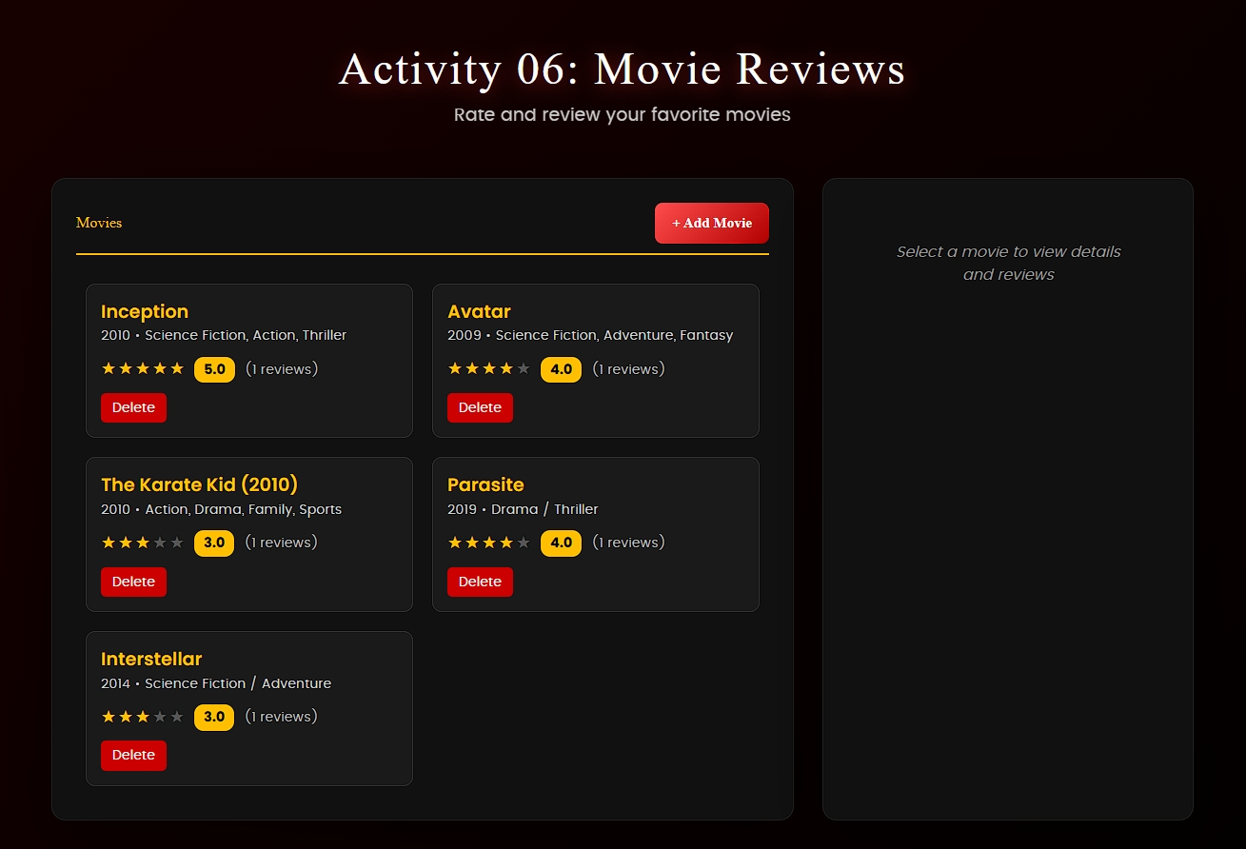

**Main page UI**

Showing movie listing featuring orange/dark red background and average scores highlighted in oranges against light black color palette.

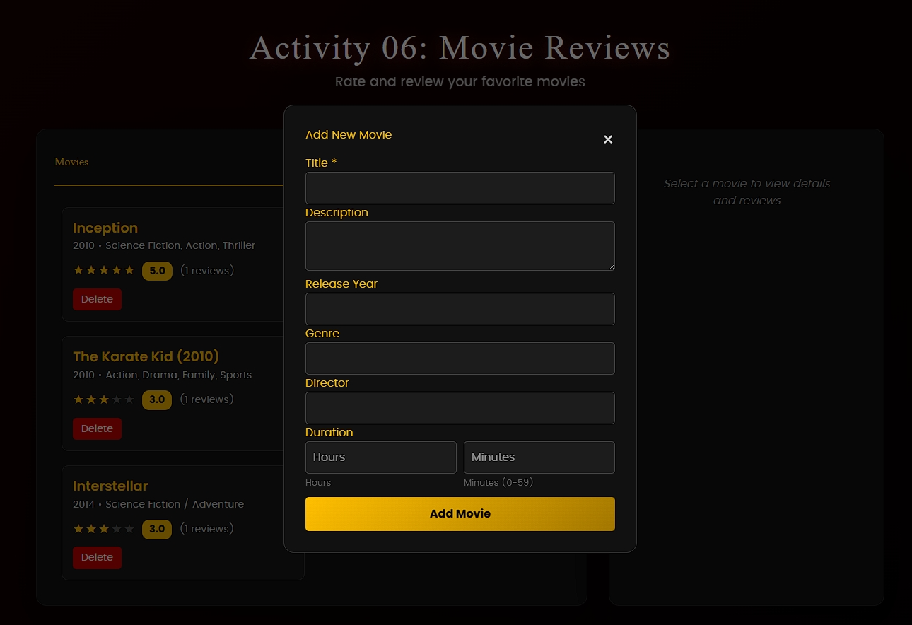

**Add New Movie Form UI**

Showing users can add a new movie using form with title input, description, release year, etc., and by clicking the "Add Movie" button to submit.

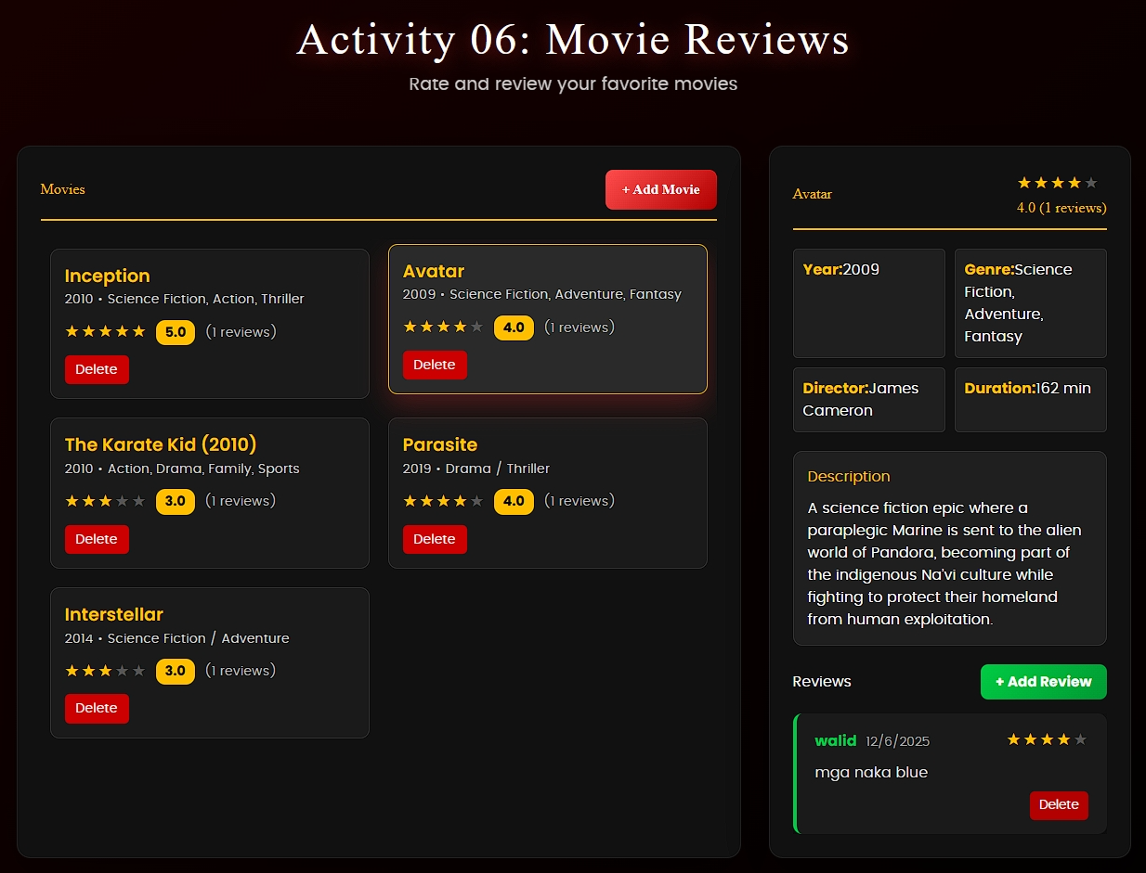

**Movie Details and Reviews View**

Showing movie details like year, genre, director, duration, description, and reviews with ratings.

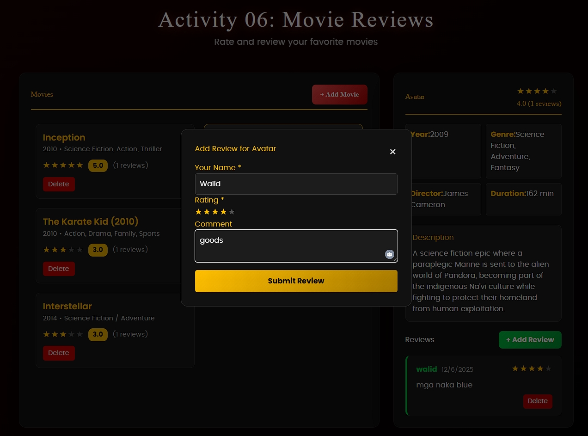

**Add Review Form UI**

Users can add reviews with name, rating stars, and comment fields.

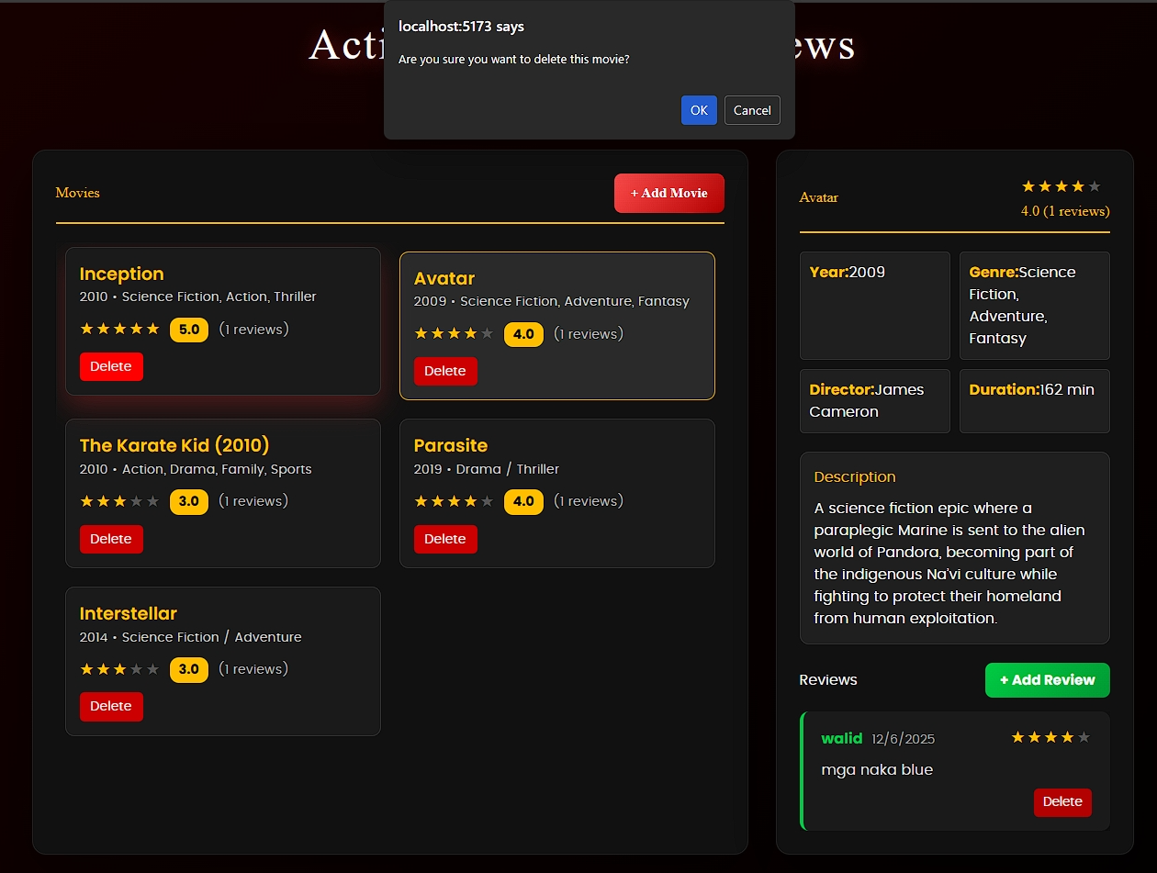

**Delete Movie Confirmation UI**

Showing "Are you sure you want to delete this movie?" popup with OK/Cancel after clicking Delete.

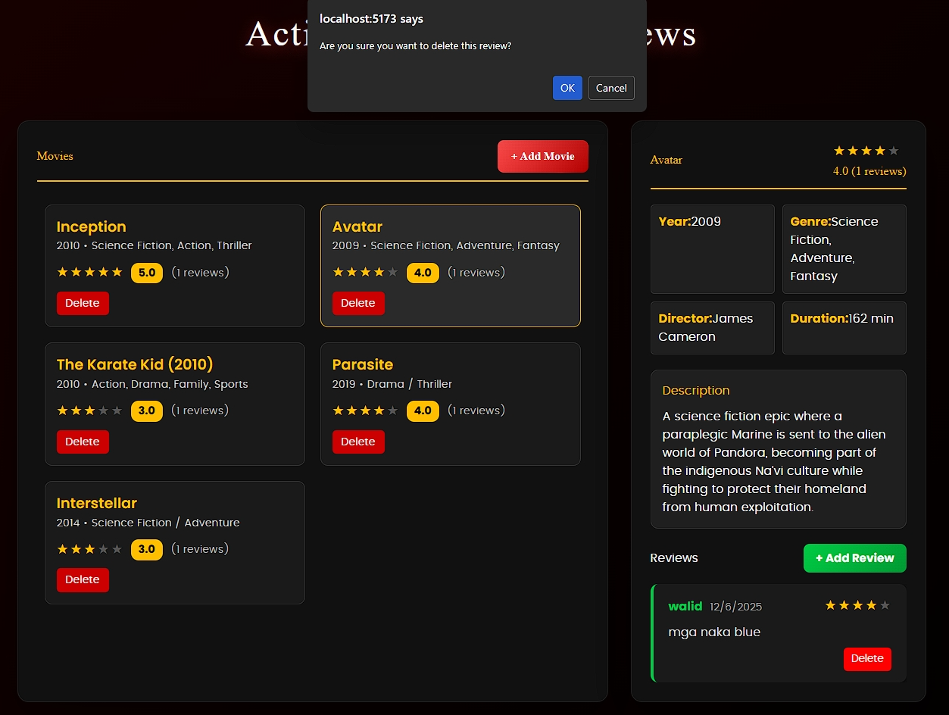

**Delete Review Confirmation UI**

Showing "Are you sure you want to delete this review?" popup with OK/Cancel after clicking Delete.

**Swagger API Documentation**

Showing interactive API endpoints documentation for movies and reviews management.

* Movie
* Review

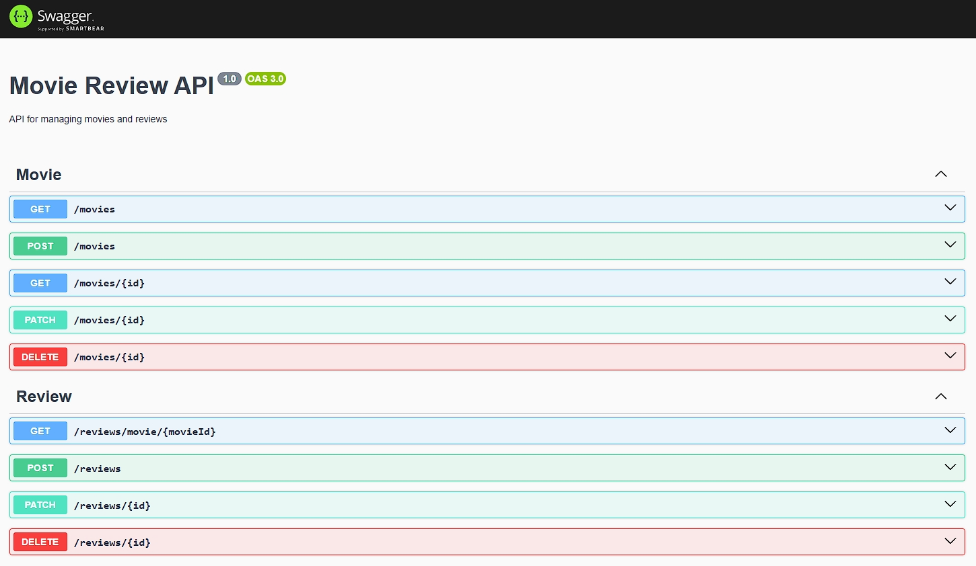

**Movie**

**GET / movies**

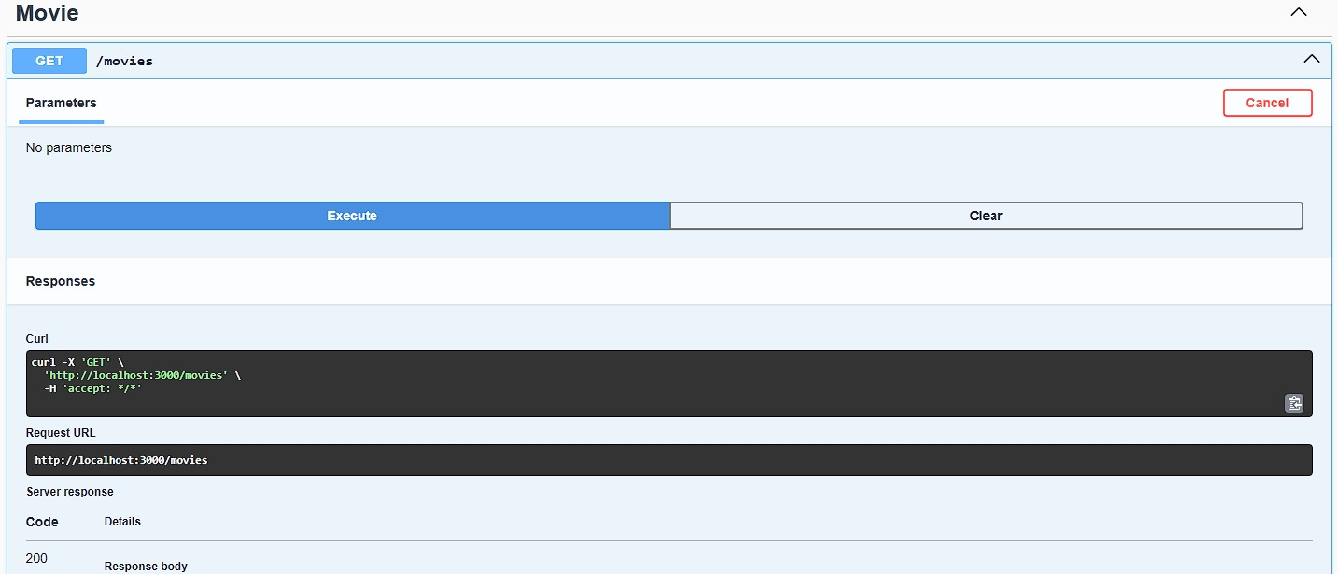

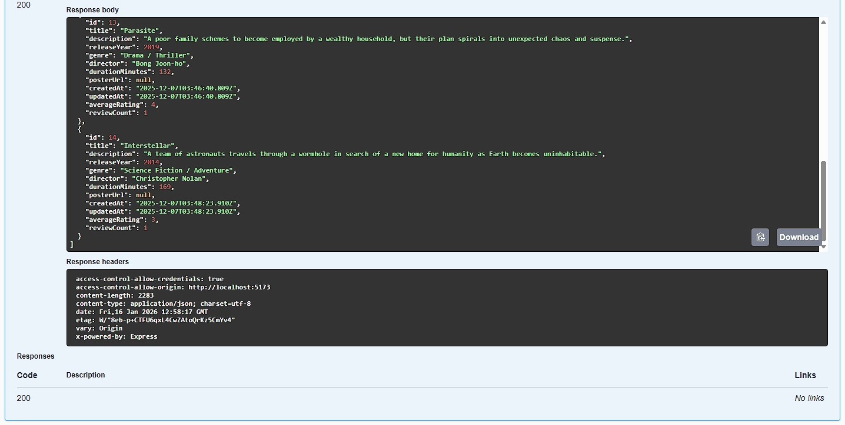

**POST / movies**

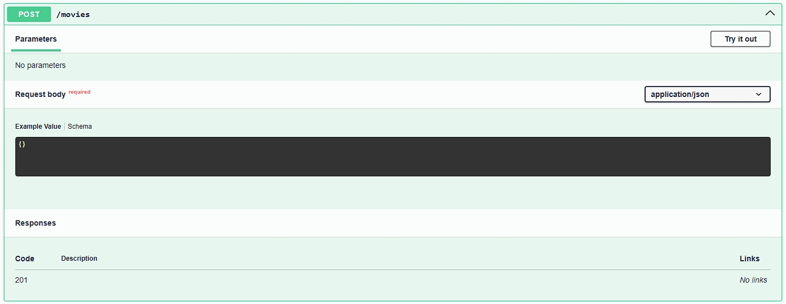

**GET / movies {id}**

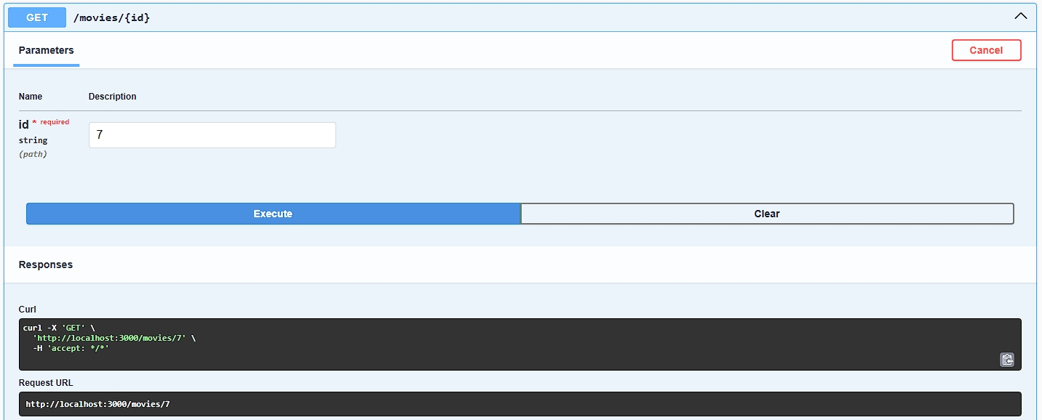

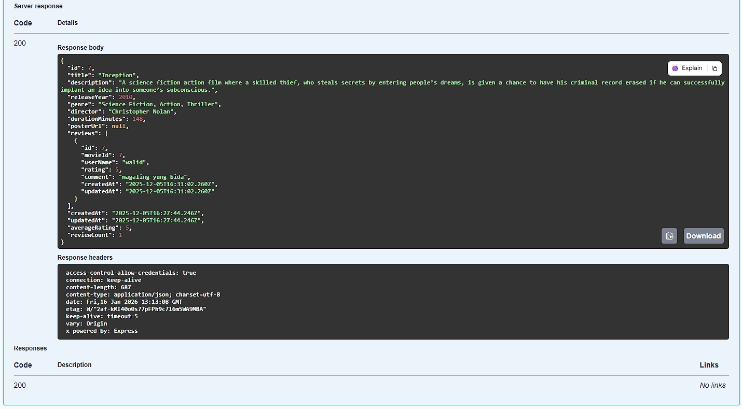

**PATCH / movies {id}**

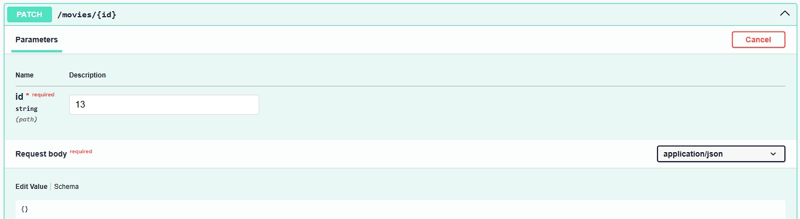

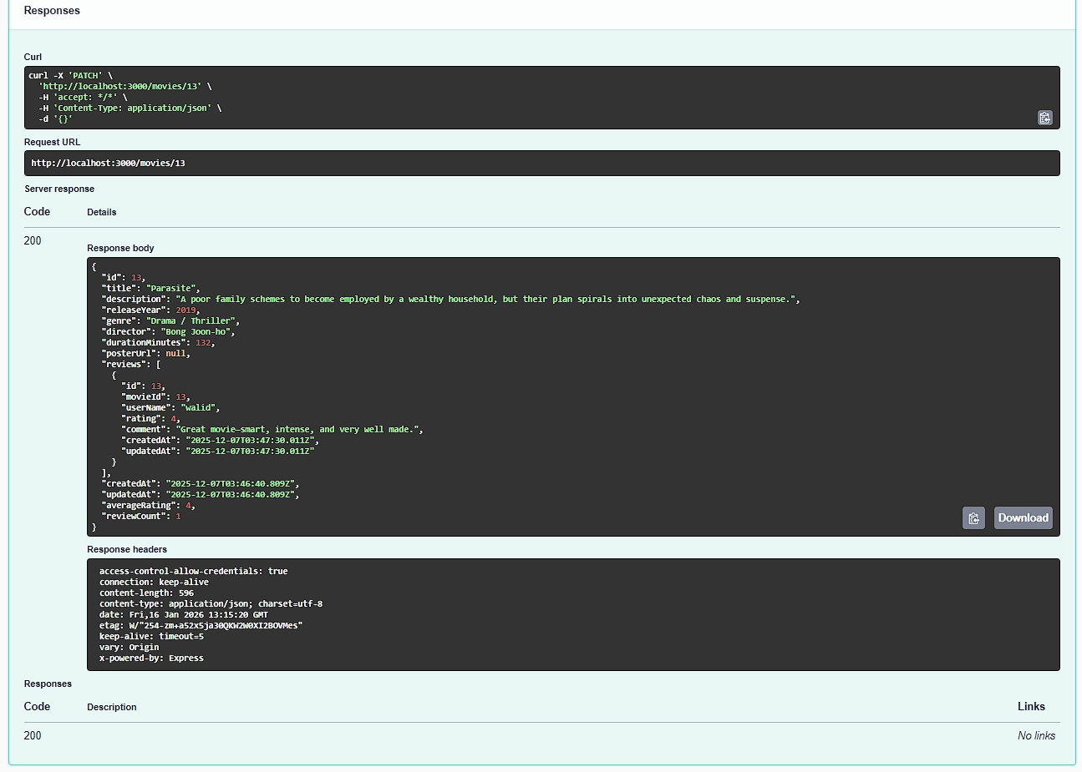

**DELETE / movies {id}**

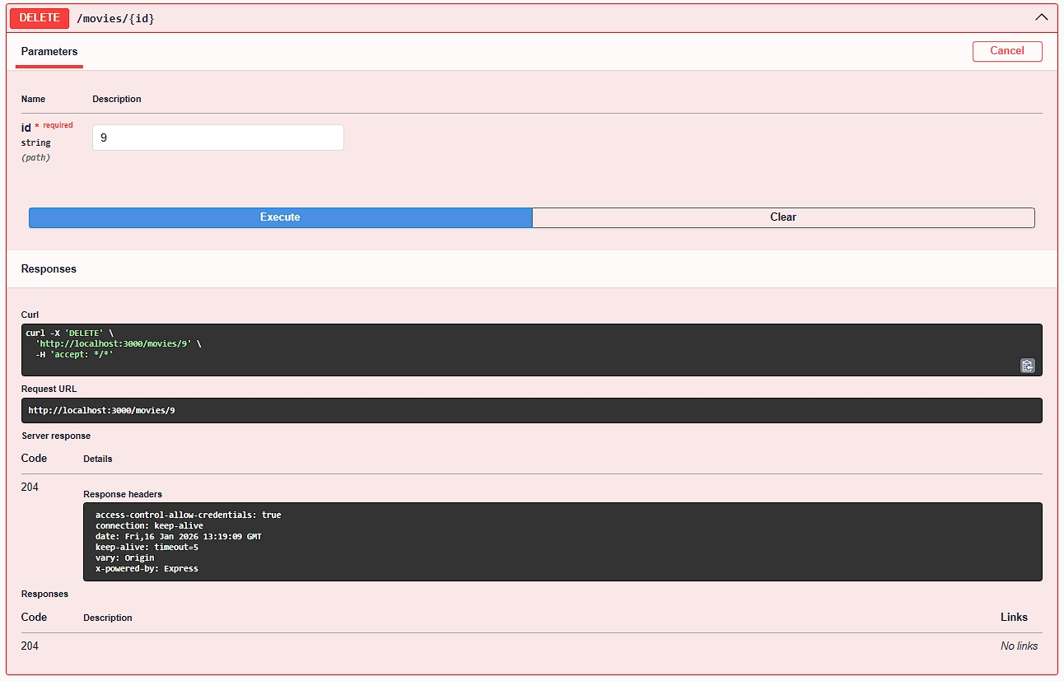

**Review**

**GET / reviews / movie / {movieId}**

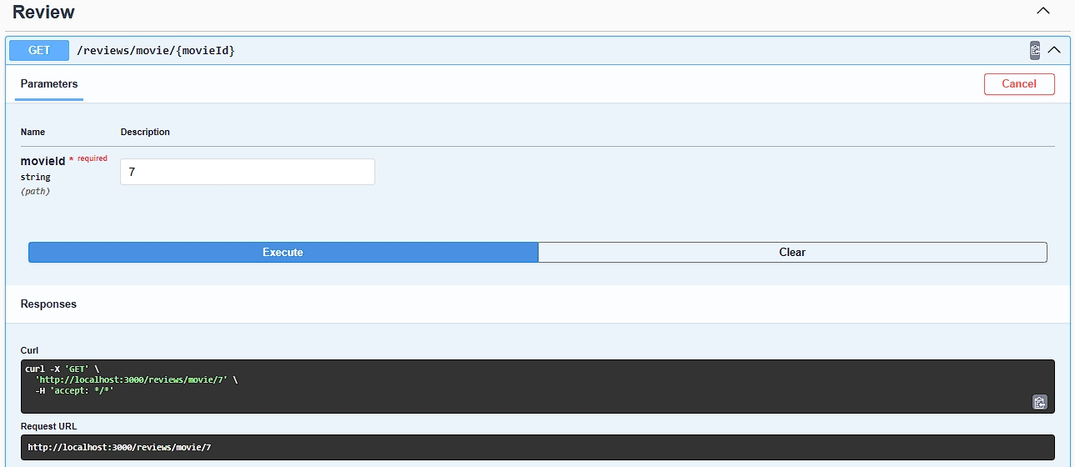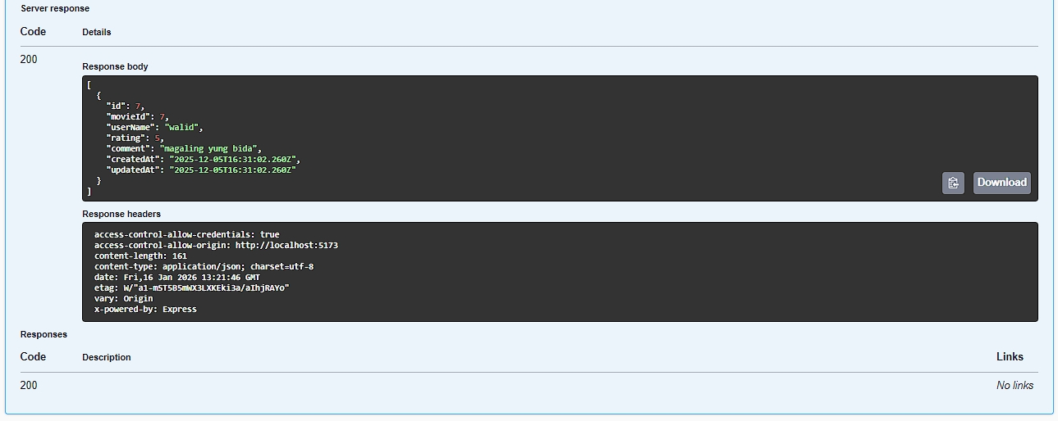

**POST / reviews**

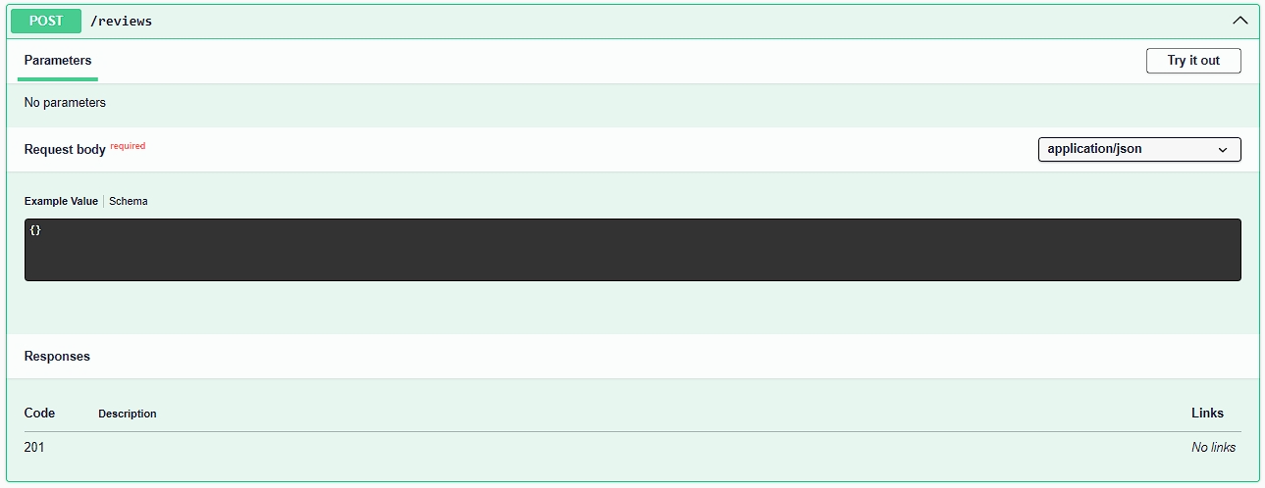

**PATCH / reviews / {id}**

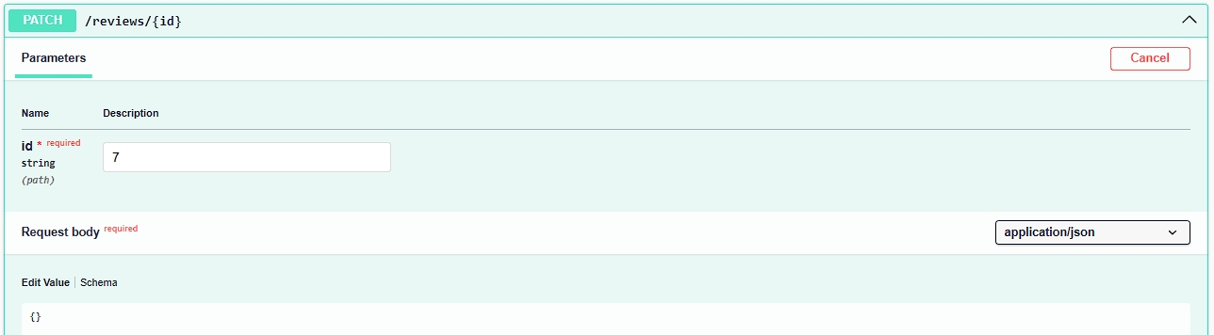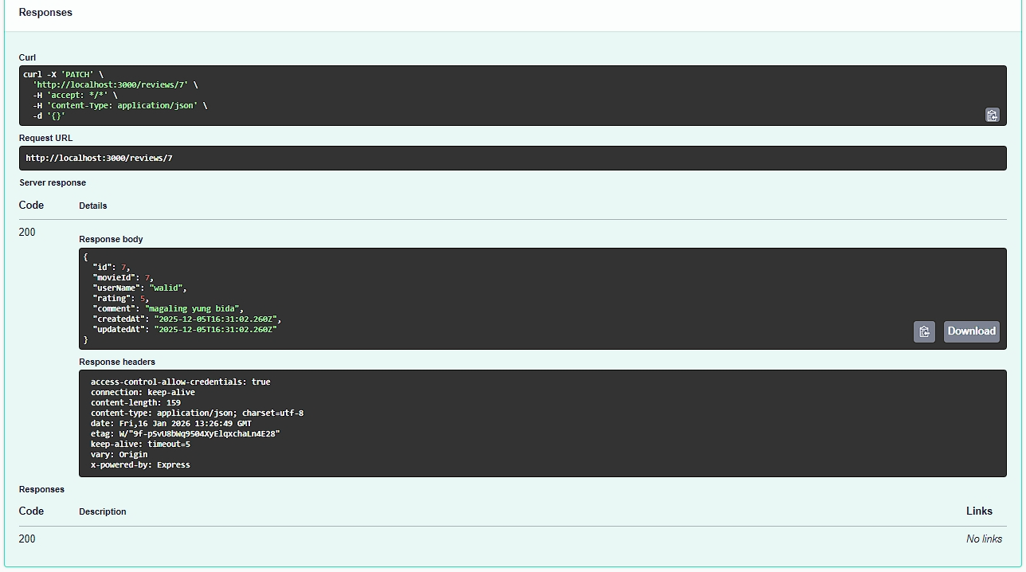

**DELETE / reviews / {id}**

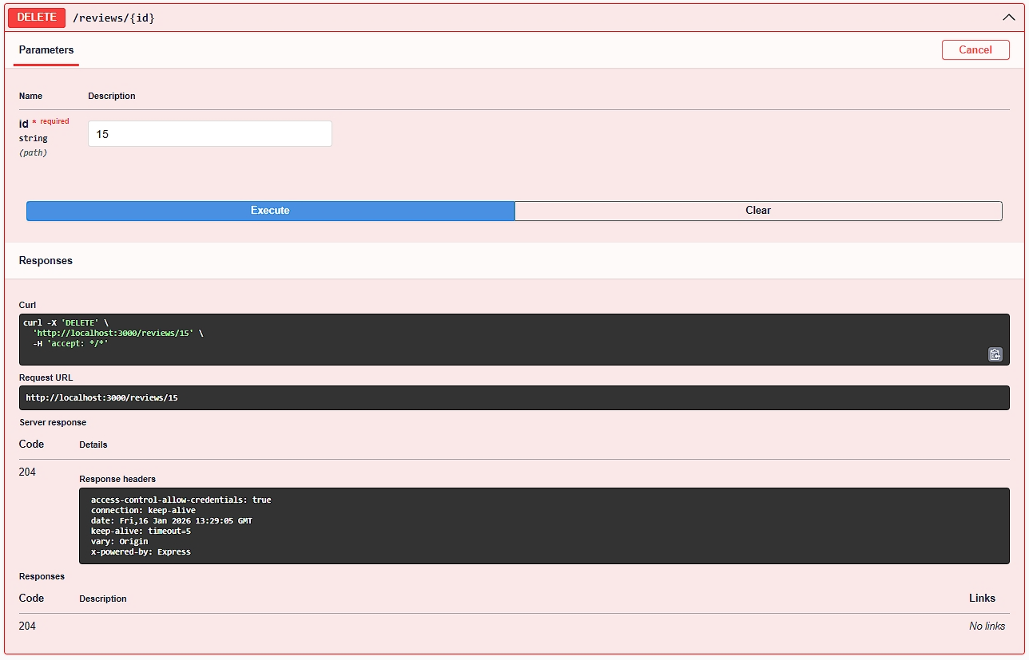

**How to Run the System:**

**Prerequisites:** Node.js (v16+), XAMPP MySQL running, database **movie_review_db**.

Backend (Terminal 1):

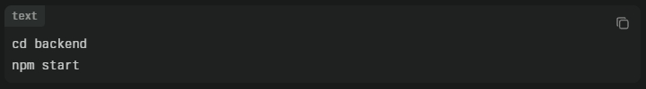

**Access:** http://localhost:3000/api (Swagger) [Keep open]

Frontend: (Terminal 2):

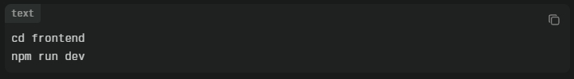

**Access:** http://localhost:5173 [Keep open]

**Test:** Add movie via Swagger → View in frontend → Add review → See average rating update.

**Stop:** Ctrl+C in both terminals.

**Conclusion**

This **Movie Review API + UI** lets people add movies, write reviews with star ratings (1-5 stars), and see average scores for each movie. Users can view movie details (year, genre, director, duration), read other people's comments, delete movies or reviews with confirmation popups, and data saves to a MySQL database.

**Swagger** provides a webpage at localhost:3000/api where anyone can see all system functions, test adding movies or reviews by filling out forms and clicking buttons—no coding needed. The dark theme with orange/red rating colors makes scores visible. This project shows complete app building from database to user interface using terminal commands to run frontend (localhost:5173) and backend together.